**LEDs**

* What are LEDs – Light Emitting Diodes
  + More efficient than traditional lighting
    - Less energy, lower cost, long life, negligible environmental and human toxicity
  + Enables improved performance and control (color, intensity, and distribution)
    - Can be used for many applications
    - Also works as fuel for fresh food production
* How it works: a blue LED is combined with optical down-converters (phosphors), absorbs a portion of blue light and emit longer wavelengths to produce white
* Benefits
  + Light intensity can be precisely controlled, modulated over a large range of frequencies (low – GHz)
  + Distribution of space can be controlled; because semiconductor LEDs emit light from small areas (have low etendue), they can be optically imaged in space with great precision.
  + LEDs are easily arrayed and can create pixelated ‘super beams’.
  + Can be easily integrated with other technologies
* Plants
  + are sentient organisms, and evolved to have become more sensitive to ultraviolet, photosynthetic and near-infrared radiation in their environment.
  + Responds to light in more ways than humans, utilizing more than a dozen photoreceptors to direct their growth
  + Live in communities and respond to light reflected from other plants
  + Use photons as fuel for photosynthesis and signal that directs plant shape and leaf color (plant development)
  + 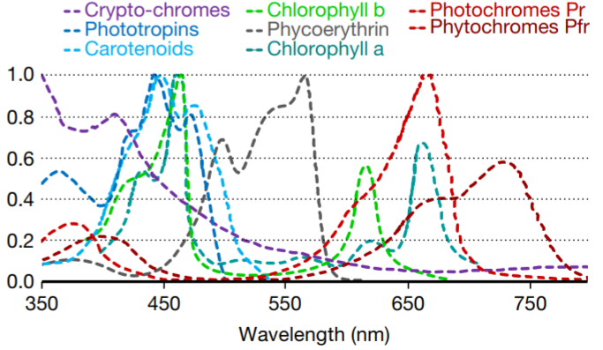Shape includes leaf expansion and radiation capture, both increases canopy photosynthesis.

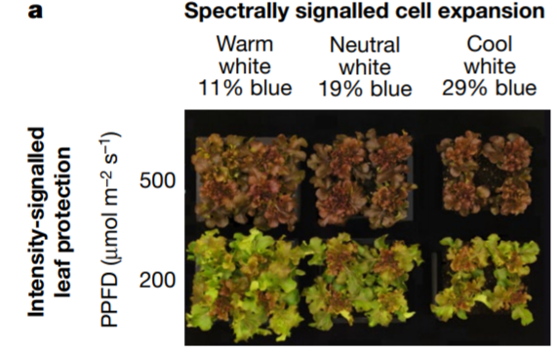

* How it can be used for plants
  + LED lights can have its color rendering indexed and temperature adjusted
    - Using this, the spectra can be engineered to stimulate photobiological responses that can alter plant shapes, increase photosynthesis and enhance nutritional value.
  + Wavelength of light effects morphology of plants, blue light affects differently across different species
  + UV Light
    - Ultraviolet radiation benefits plant growth;
      * Increased cuticle thickness
      * Reduced intumescence
      * Increased secondary metabolism (improves flavor)
    - UV also affects interaction between plants, fungal pathogens and insects (vary across species)
      * Near infrared radiation (700 – 780 nm) effects stem elongation and rate of leaf expansion greatly,
        + Primary receptor (phytochrome) becomes well characterized
        + More being discovered
  + Green Lights.
    - Chlorophyll only absorbs small quantities of green light (ppl think its bad for photo)
      * But, because it penetrates deeper into leaves and plant canopies, green photons also have similar value in photosynthesis like other colors
  + Studies show… (also being studied)
    - LEDs were tested at photosynthetic photon flux density (PPFD) of less than 10% of full sunlight, at higher light intensities, morphological effects in low light can be reversed.
    - Blue photons interact with total PPFD to determine cell expansion, elongation of the petiole, stem and leaf
      * Also, indirectly, radiation capture via morphology changes
    - The timing of the delivery of photons can help to understand the photobiological mechanisms and sites of perception
    - LEDs can pulse ultraviolet radiation to improve flavor and minimize the detrimental effects UV radiation on DNA
    - important to scale from monochromatic short-term measurements on single leaves to long-term performance of plant communities
      * important because plants adapt to changes in radiation by synthesizing new pigments
    - Changing quality of light alter shape of plant
    - Having multiple wavelengths interact synergistically has many effects
  + They are still in research and no real conclusion, still asking questions

**Light Chapter 7, Plant Factory**

* Light has 2 contradictory properties: as wave phenomenon and discrete particles: photons
  + Light varies in 3 dimensions: quantity, quality and duration.
* How do lights affect plants?
  + Provides energy or quantum source
    - Light is captured by plants and a bit (10%) of photons is converted to chemical energy (carbohydrates) through photosynthesis
    - Most become heat energy.
  + Acts as an information medium.
    - Can show when a plan is developing in processes like photomorphogenesis and photoperiodism
    - Photoreceptors in plants function as light sensors to sense how light changes so that the plant can control its physiological and morphological responses
* **Daily Light Integral (DLI)**, different for different plants
  + Total amount of light received by plants in a day relates to plant growth, development and quality.
  + In **Plant with Artificial Light (PFAL)**, light intensity is usually kept constant, so DLI can be easily calculated from PAR and photoperiod
* Light Spectral Distribution/ Composition.
  + Is the light quality; affects plant growth and morphology
  + Measured by spectroradiometer, to determine characteristic of light source
* Light Emitting Diodes (LED)
  1. General benefits
     + Better than incandescent, fluorescent and HID; more robust, stable output, long lived, compact, lightweight, instantly turn on, controllable output
     + Colors can be changed and adjusted as needed
     + For PFAL; offers great flexibility for producing various light environments for different plants
       - 例: Light source with different wavelength of LEDS can produce light that has its spectral radiant flux varying over time
  2. Configuration types
     + Lamp type (round type; through-hole)
     + Surface mount device (SMD)
  3. Terms for Electrical and optical characteristics
     + Forward current: max current allowed for continuous operation (there’s also pulsed forward current)
     + Luminous intensity (cd): luminous flux emitted into a solid angle [sr] of space in a specific direction
     + Radiant flux/power: amt of E emitted per unit time
     + Peak wavelength
     + Half width
     + Viewing half angle: angle from LED optical axis where intensity is max and radiant intensity reduced to half max at 0 degrees
  4. Electrical and thermal characteristics when operational
     + Current flowing thru LED increases exponentially with increasing voltage applied to LED
     + When ambient temperature is constant, spectral radiant flux is proportional to current flowing through LED
     + Even if current is constant, spectral radiant flux (and luminous intensity) decreases with ambient temperature
     + Max forward current drops sharply after 40 degrees.
  5. Control of lighting and light intensity
     + 2 methods of lighting; ‘truly’ n ‘apparently’ continuous light during photoperiod
       - ‘truly’; continuously ‘in a strict sense’
       - ‘apparently’; intermittent light (in a short time cycle), also pulsed lighting (especially when one-cycle time is below 1s)
     + Controlling;
       - Constant-current operation; controlling the current sent
       - Constant-voltage operation; but only when temperature is constant in LED chip and ambient air
       - Method ‘pulse forward current’
         * Repeatedly turning on and off LEDs at extremely short intervals by breaking and applying current (for pulsed)
  6. Disadvantages
     + High initial cost for a set of LED light sources (includes components for mount, operate and protect)
  7. Different colored LEDs for PFAL
     + Most common combination: blue LED (peak λp 460nm) and red (λp 660nm)
     + Red and white (blue chip using yellow coated phosphor) also used
       - 例: in Netherlands, combination of blue, red and far-red already used for commercial productions of lettuce seedlings
     + If combination of green/violet/ultraviolet with blue and red shows improvement in plant growth or increase in nutritional value and beneficial to human health, it could be used.
     + What if only 1 color? choose smth with a spectral power distribution similar to sunlight at ground level.
  8. Pulsed lights and effects
     + From current studies, pulsed lights do not promote photosynthesis or plant growth greatly as long as the spectral photon flux density (spectral irradiance) is constant over time

**Light Adequacy in Tropical Places**

* All Crops react differently to light even though their daily light intake is similar/ close to each other
  + - High light intensities can reduce plant growth cycle (cucumber), faster growth
    - Using supplementary lighting to increase photoperiod to 16-24 hours and spreading out intensity of instantaneous PAR levels show an increased biomass in numerous crops.
    - Long photoperiods can lead to leaf chlorosis or other negative symptoms
    - For places like Singapore which is tropical, a 12h photoperiod is good comparison to natural light conditions
  + For Crop cultivation, we must consider the plants ability to acclimatize to varying irradiance levels provided by unnatural lights
    - Includes; crops ability to adapt to varying levels of cumulative PAR
    - , and abrupt changes to instantaneous PAR
    - Poor light acclimation can result in plants being in low-light stress or photoinhibition under insufficient/ excessive levels of PAR
    - Some plants (like cabbage) cant withstand high PAR
      * High light and temperature is bad
      * On the other hand it might be good for other crops
  + There are other factors, always;
    - Water availability
    - Temperature
    - Levels of carbon dioxide
  + Greenhouse vegetables require high light levels, but excessive temperatures can lead to lower yield and contribute to heat stress and photoinhibition.
    - High light and cool temperatures enable the most energy to be channeled towards growth, resulting in large, high-quality plants.
  + Temperatures affect bolting, negatively influencing size, texture and taste of leaves
    - More studies being done. Even in Singapore, T range is from 25 – 36 daily, even reaching up to 42 degrees
  + Plants with higher light saturations can be more resilient to harsh conditions
  + Design examples;
    - Using frosted glass/ mechanisms to evenly distribute insolation across different directions and heights
    - Plants require building models that can delay the transfer of heat
      * From outside sources and the sun
      * Type, topography, material of buildings are important to accommodate the high-light requirements of crop plants
    - Suggests building facades that experience minimum half a day of direct insolation will support growth for moderate-very high light DLI categories